Final Result:

GET: <http://localhost:8080/spring/database>

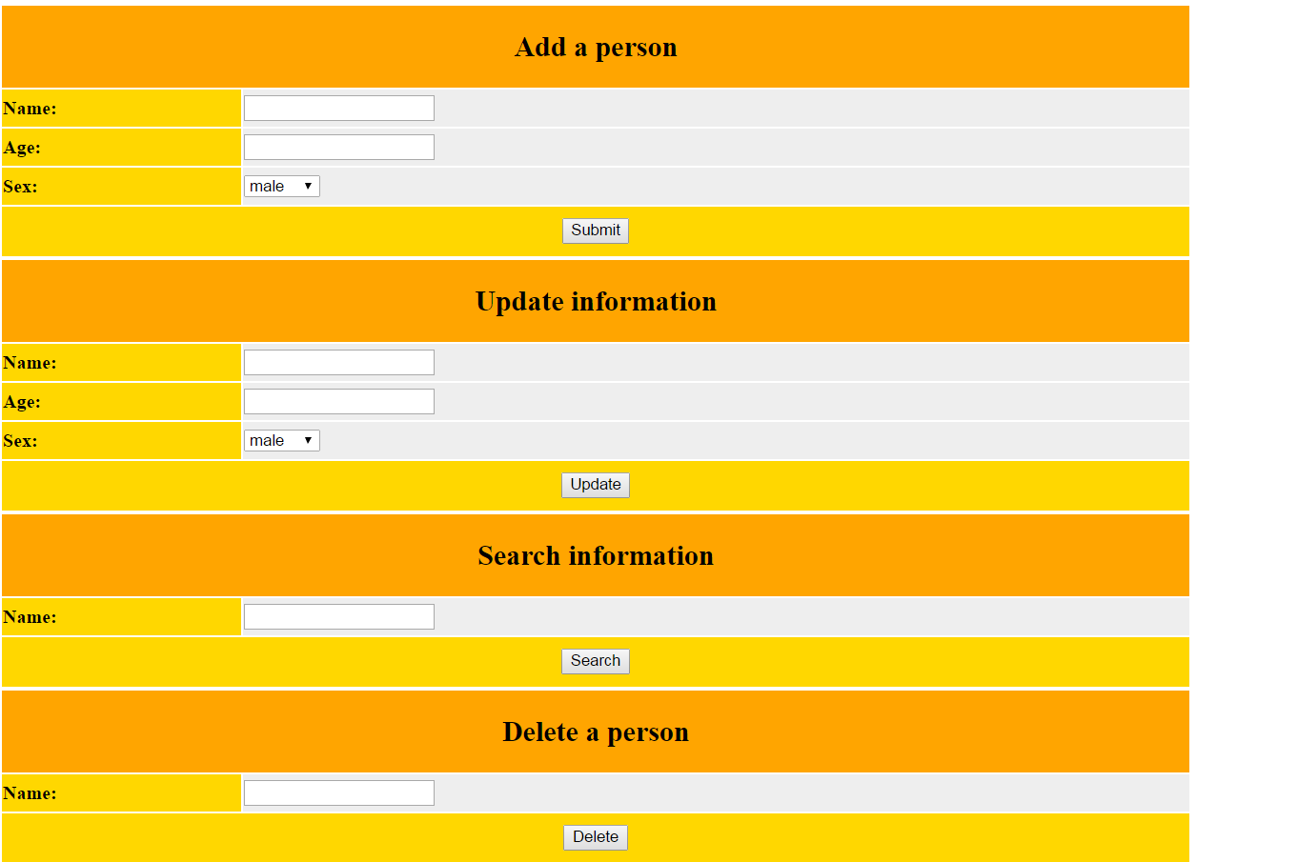

POST: Add new document to store

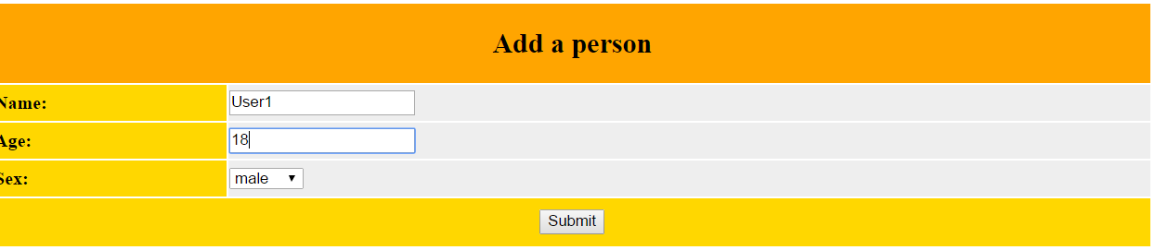

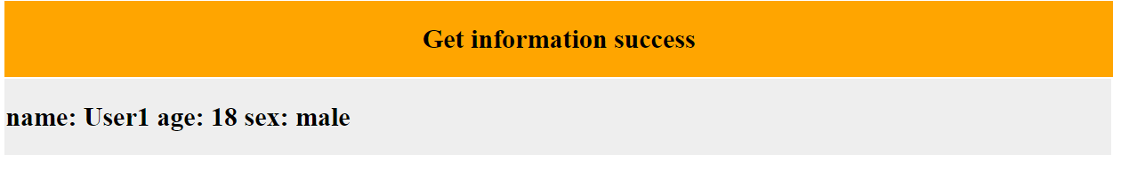

POST: Search a document

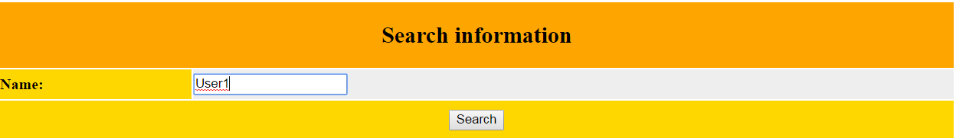

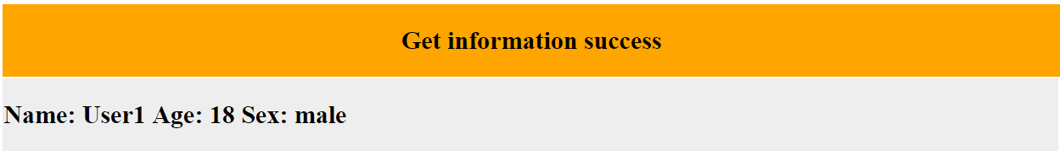

POST: Update a document

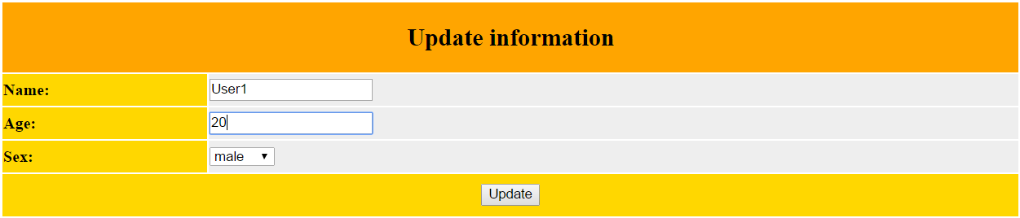

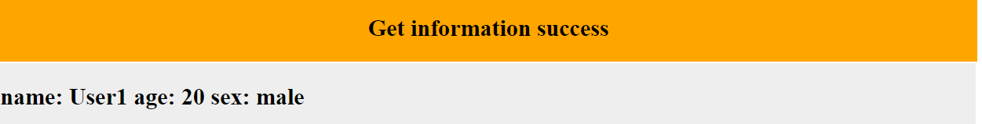

POST: Display all documents

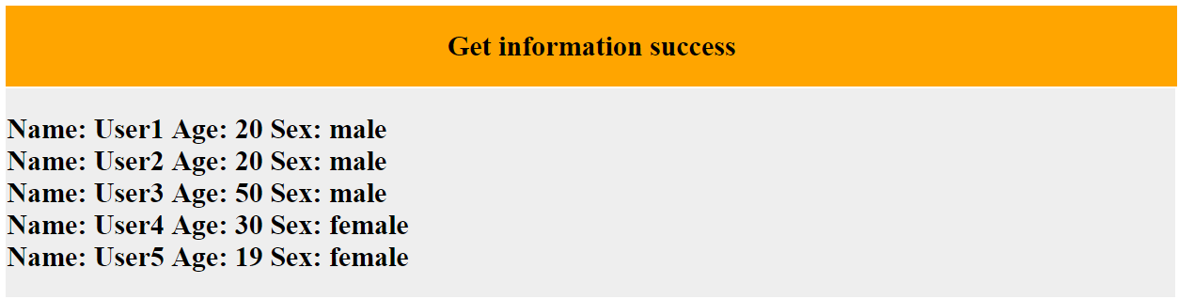

POST: Delete a document

